Deploy LMS application
Frontend: react
Backend: java
Database: MySQL

Java code: https://github.com/digital-lync-2023/lms-team-1/tree/praneeth

Create instance with
>ubuntu
>t2 medium:4gb memory/2 CPU
>default vpc
> Default security groups
> Security credentials with
Port numbers:80/8080/3306/{give them all traffic if you want}
- Create instance

>sudo apt update
>docker
Docker installation
>docker
> curl -fsSL https://get.docker.com -o get-docker.sh
sh get-docker.sh

>docker
>sudo usermod -aG docker ubuntu

>logout

Java installation
> sudo apt install openjdk-17-jdk openjdk-17-jre
>java
Clone the code from the repository
>git clone https://github.com/digital-lync-2023/lms-team-1/tree/praneeth

Database installation :
>docker login #login into docker hub
>docker pull MySQL
#Create a password for the database in this path
>LMS-BE/src/main/resources/application.properties
#change the password update the IP address
>docker run --name <mysql-container> -e MYSQL_ROOT_PASSWORD=password -d mysql
#login to my SQL
>docker exec -it < mysql-container-name> mysql -uroot -p
>SHOW DATABASES;
>SHOW TABLES;
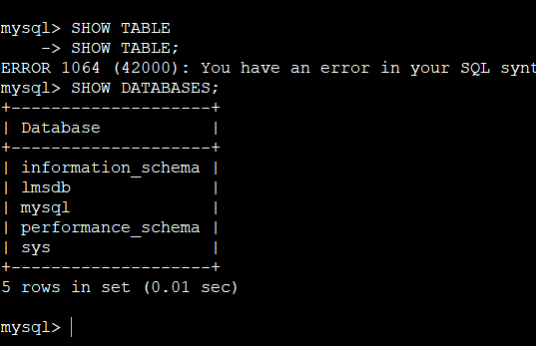
>exit
#In LMS-BE create /modify Dockerfile
>vi Dockerfile
# Use the official OpenJDK 17 image as the base image
FROM openjdk:17

# Maintainer information
LABEL maintainer="praneeth"

# Set the working directory inside the container
WORKDIR /app

# Copy the entire project to the container's working directory
COPY . .

# Run Maven clean package to build the application
RUN ./mvnw clean package -DskipTests

# Expose port 8080
EXPOSE 8080

# Define the entry point for the container

ENTRYPOINT [ "java","-jar","target/lmsbe.jar" ]

Escape + :wq! #{for quit}
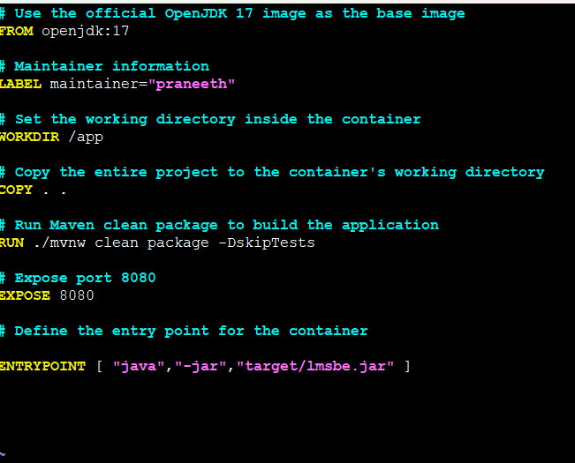
#for build docker command
>docker build -t lmsbe:001 .
>docker images
#using docker backend image create a container
>docker run -dt --name lmsbecon1 -p 8080:8080 -e DB_HOST=<mysql IP> -e DB_PORT=3306 -e DB_NAME=lmsdb -e DB_USER=root -e DB_PASSWORD=<admin123> <be image name>
#for docker IP address checking
>docker inspect <container name>

#For checking backend to database connection
>http://<localhostIP>:8080/user/connect
#for the container health check
>docker container logs <container name>
>curl localhost:8080/user/connect
>docker tag lmsbe:latest docker.io/<github ID>/lms:latest
>docker push docker.io/<github ID>/lms:latest
>cd ..
>cd LMS-FE-REACT/
>/src
#Connect backend to frontend connection

>vi utils.js
>cd ..
>vi docker
FROM node:20 as build
WORKDIR /app
COPY package*.json ./
RUN npm install
COPY . .
RUN npm run build
FROM nginx:latest
COPY --from=build /app/build /usr/share/nginx/html
EXPOSE 80
CMD ["nginx", "-g", "daemon off;"]

>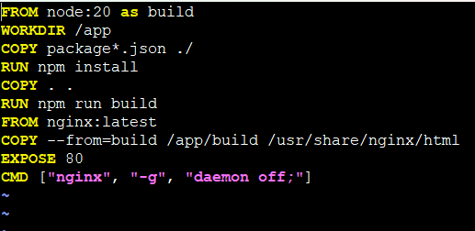
>docker build -t lmsfd:001 .
>docker images
>docker container run -dt –name lmsf -p 80:80 lmsfd:001
>docker ps
# check the output with IP addess
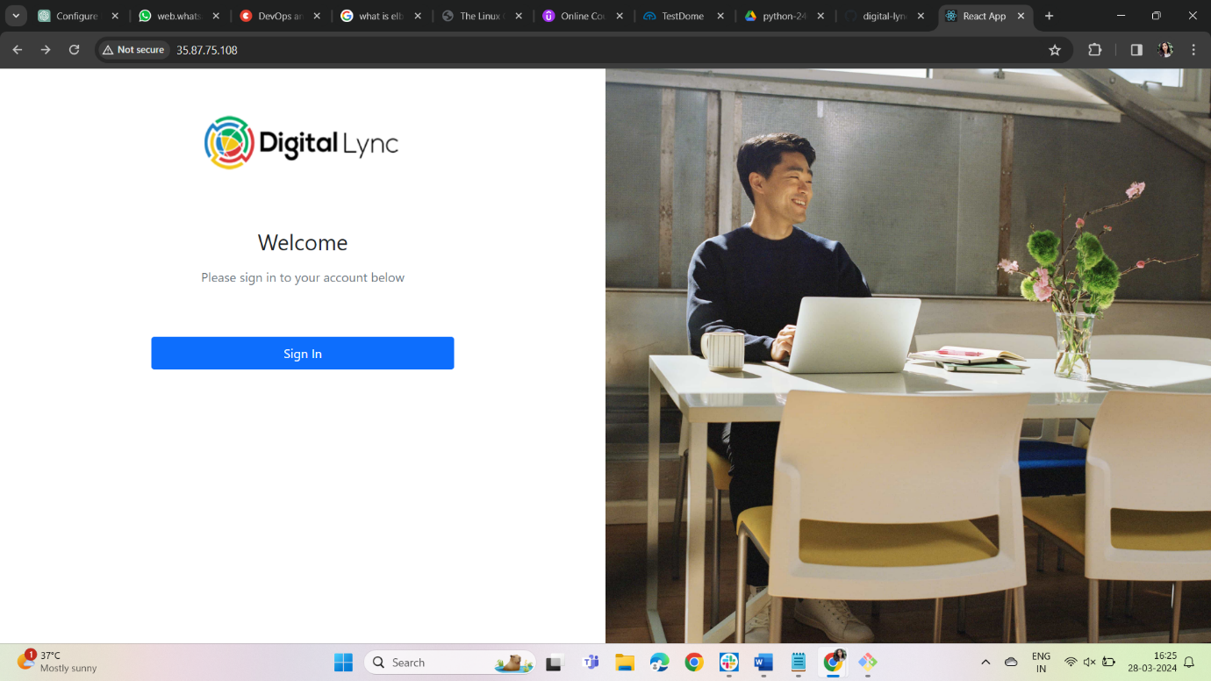
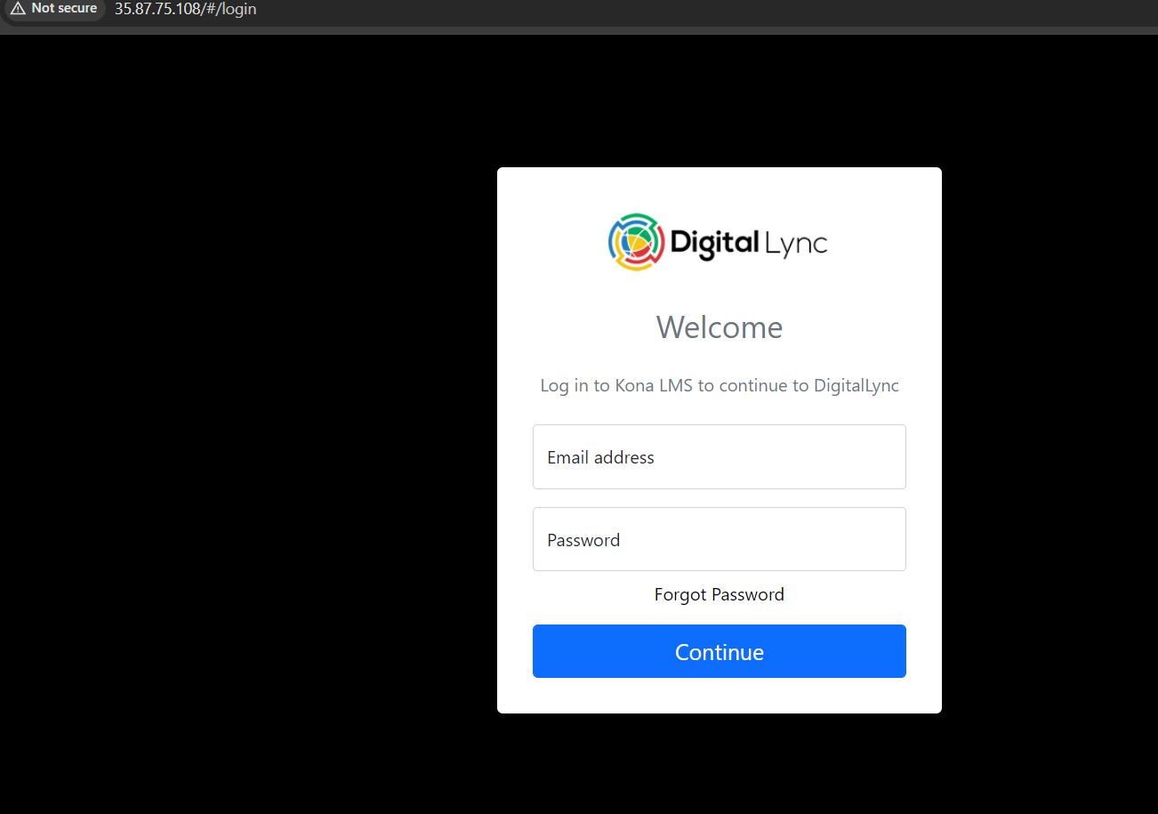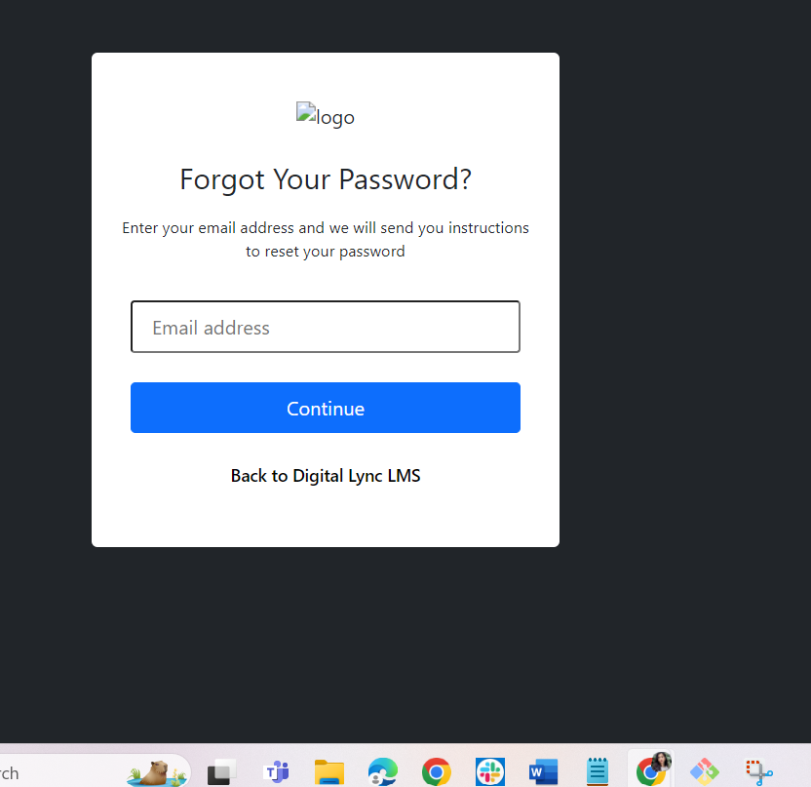
> jessie@digital-edify.com
>abc123


